Chapter 1, Problem 17.

Figure 1.28 shows a circuit with five elements. If
p₁ = –205 W, p₂ = 60 W, p₄ = 45 W, and p₅ = 30 W,
calculate the power p₃ absorbed by element 3.

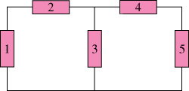

Figure 1.28
For Prob. 1.17.

